**DAILY ONLINE ACTIVITIES SUMMARY**

|  |  |  |  |  |  |  |  |
| --- | --- | --- | --- | --- | --- | --- | --- |
| **Date:** | **27-05-2020** | | | **Name:** | | **B.A.SOHANKUMAR** | |
| **Sem & Sec** | **4TH SEM A** | | | **USN:** | | **4AL18CS013** | |
| **Online Test Summary** | | | | | | | |
| **Subject** | | **OBJECT ORIENTED CONCEPT** | | | | | |
| **Max. Marks** | | **30** | | | **Score** | **26** | |
| **Certification Course Summary** | | | | | | | |
| **Course** | **INTRODUCTION TO ETHICAL HACKING** | | | | | | |
| **Certificate Provider** | | | **GREAT LEARNING ACADEMY** | | **Duration** | | **6 HOURS** |
| **Coding Challenges** | | | | | | | |
| **Problem Statement:1:**Write a C program to sort an array of integers in ascending order and display the sorted array and number of passes performed for sorting. | | | | | | | |
| **Status:Executed** | | | | | | | |
| **Uploaded the report in Github** | | | | | **YES** | | |
| **If yes Repository name** | | | | | **LOCKDOWN CODING** | | |
| **Uploaded the report in slack** | | | | | **YES** | | |

**ONLINE TEST DETAILS:**

The online test was from module 4 of OBJECT ORIENTED CONCEPT(18CS43).Duration of test is 30 minutes from 9.15am to 9.45am .30 questions of multiple choice.



**CERTIFICATION COURSE DETAILS:**

Course: INTRODUCTION TO ETHICAL HACKING

1,Career and Growth Ladder in Ethical Hacking.

2.Domains and Process Implementation under Ethical Hacking.

3.Ethical Hacking in Network Architecture-Demonstration.

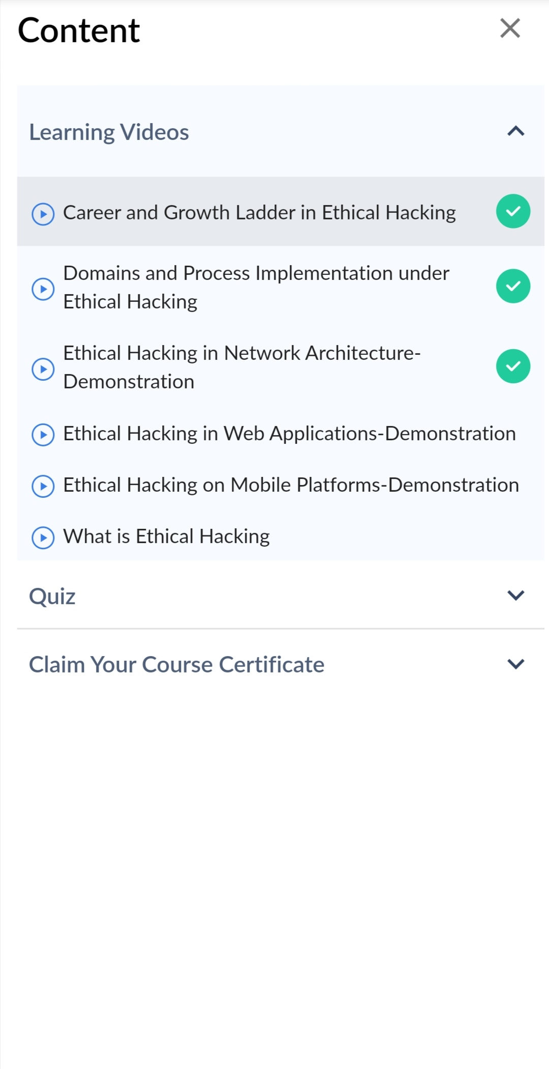

**CODING CHALLENGES:**

1.Write a C program to sort an array of integers in ascending order and display the sorted array and number of passes performed for sorting.

In Bubble sort, each pass consists of comparison each element in the file with its successor (i.e. x[i] with x[i+1]) and interchanging two elements if they are not in the proper order. The array may be sorted in any pass. If the array is sorted, then remaining passes should be skipped off.

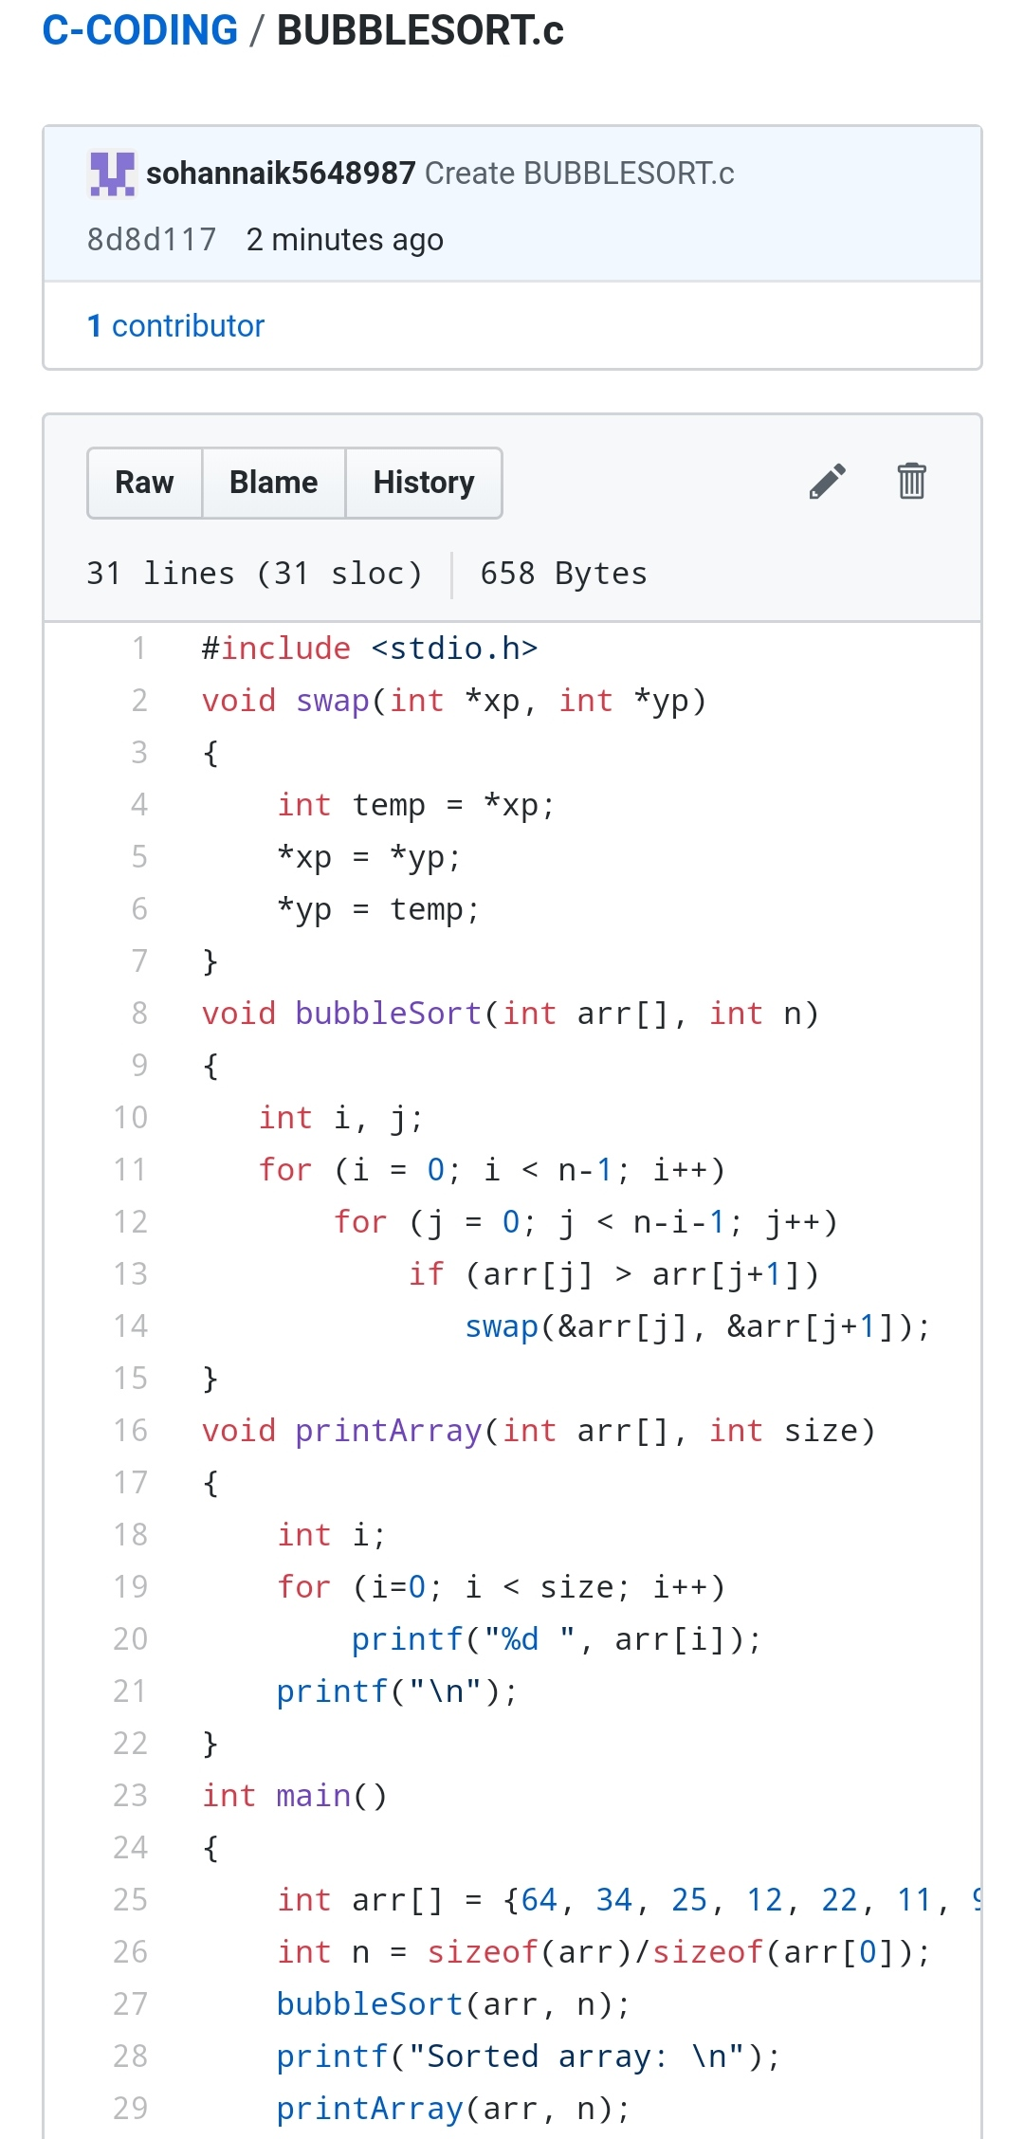

REPOSITORY LINK:1.https://github.com/sohannaik5648987/C-CODING